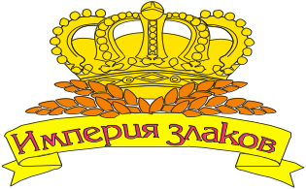

Industrial Private Unitary Production Enterprise «Smorgon Plant of Bread Production»

20, Komsomolski Lane, Smorgon, 231042, Republic of Belarus

Industrial Private Unitary Production Enterprise «Smorgon Plant of Bread Production» was put into operation on December 30th 1974. The main field of activity of the enterprise is processing of grain (cereals) and oil-bearing crops into food and compound feed, production of pork.
Our motto is : To each customer qualitative and safe products.
Nowadays the enterprise makes its production under a trade brand “The Empire of Cereals” of the following range:
-flakes not demanding cookings (oat flakes, pearl-barley flakes, buckwheat flakes, flakes from grain of a rye and wheat);
-mixes of flakes (oat and pearl-barley, oat and pearl-barley and wheat, oat and pearl-barley and wheat and rye, pearl-barley and wheat, oat and pearl-barley and wheat and rye and buckwheat, oat and wheat, wheat and buckwheat, rye and buckwheat, oat and buckwheat, pearl-barley and buckwheat);
-porridges not demanding cookings (with raisin, apple, apricot, pineapple, mushrooms);
-grains ( oat not shredded, oat swaged grain);
-oat flour.

Also the complex makes and realizes:
-rape not refined oil
-pork
-compound feed
-fodder mixes in assortment.
The quality management system of production in relation to production of processing of grain (flour, grain, flakes not demanding cooking), compound feeds, fodder mixes, vegetable not refined oils, food concentrates conforms to requirements of STB ISO 9001-2009.

